FACULTY EVALUATION
Programme Name: SBVP ALUMNI MASTERCLASS - SCALE Module I Online Kenya (20th April 2026 - 24th April 2026)
Session: Business Plan reviews
Faculty Name: Dr. William Murithi
No. of Respondents: 8
No. of Participants: 10
Evaluation Parameter | (%) Individual Score | (%) Programme Average
Punctuality (Commencement and Completion of Sessions) | 98 | 96
How well do you understand the core concepts presented? | 90 | 90
Rate your confidence in applying the new skills learnt | 88 | 84
Degree of Faculty preparedness for the sessions | 95 | 94
Content and methodology of the program | 95 | 93
Quality of class and group discussions | 90 | 90
The information presented in the course is relevant to my work (ministry) | 90 | 93
Average scores | 92 | 91

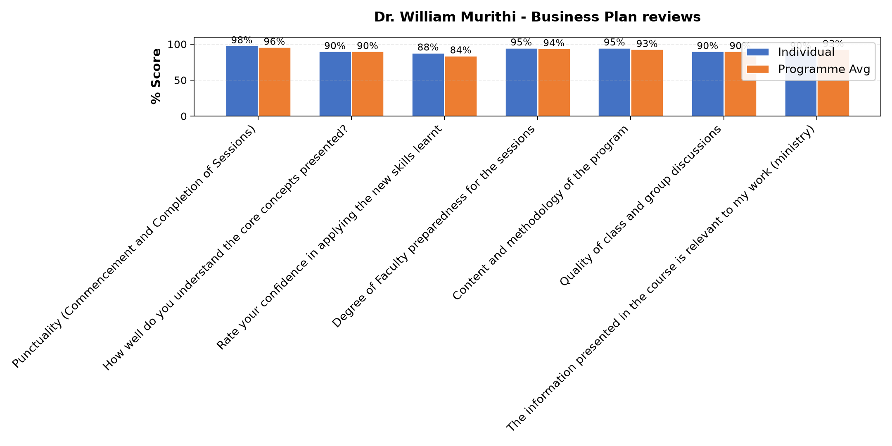

Comments & Feedback
- • None that I know
- • Organisational structures
- • The fear of failure due to luck of collaboration over competition.
- • Time
- • Limited resources
- • Lack of resources
SUBMITTED THROUGH:
SBS Evaluation Automation System

